|  |  |
| --- | --- |
| **Test Case #** | **Test Description** |
| 001 | CDR file processor testing |

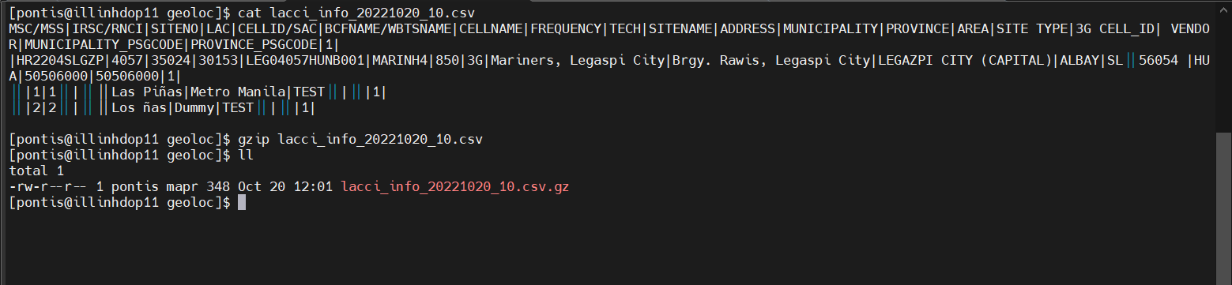

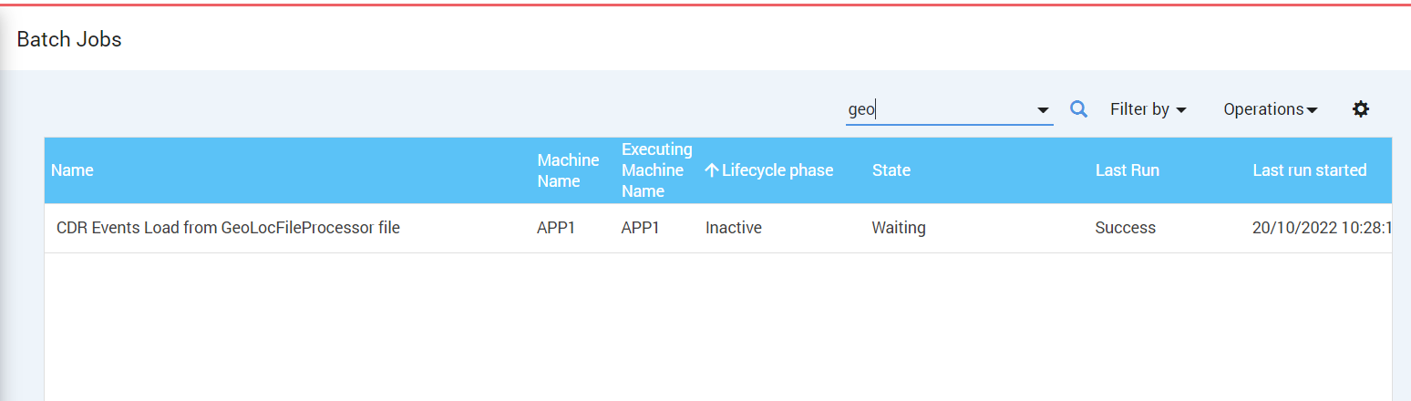

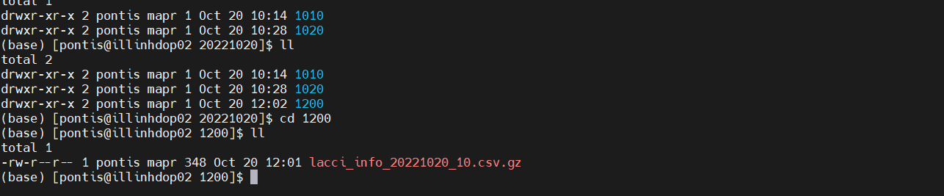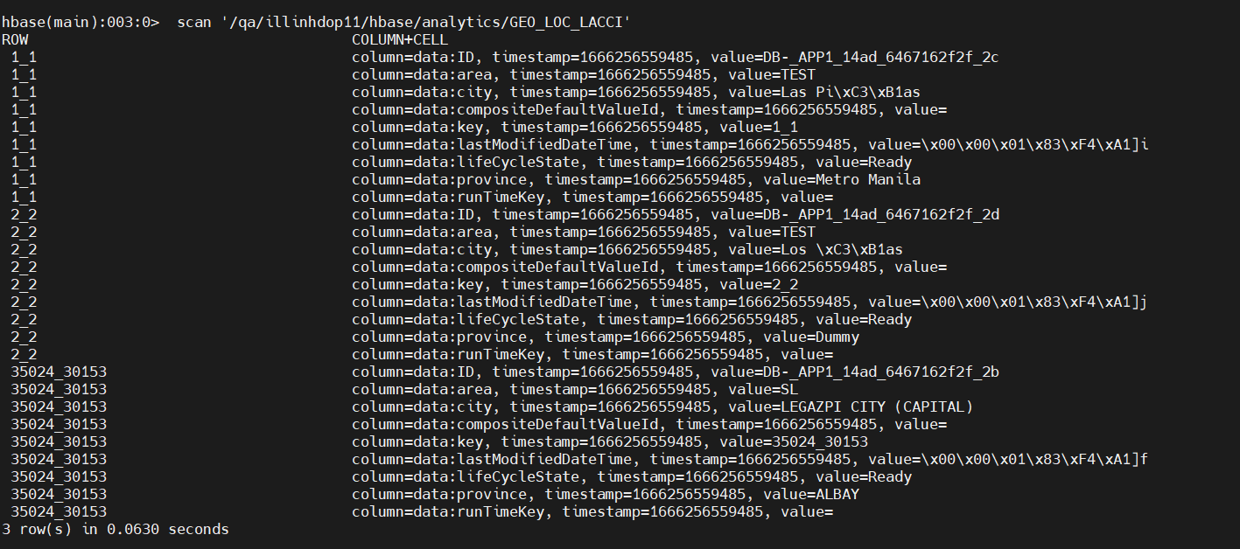

|  |  |
| --- | --- |
| **Test Case #** | **Test Description** |
| 002 | Data save to Hbase or not |

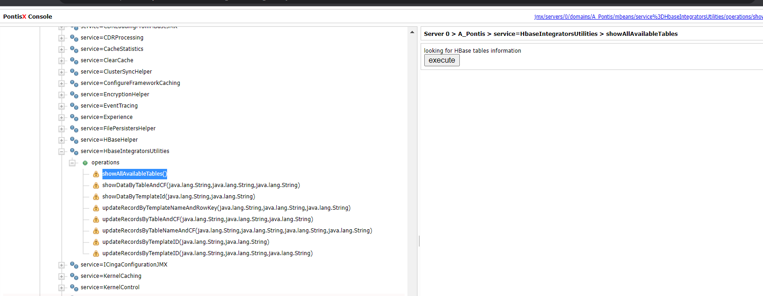

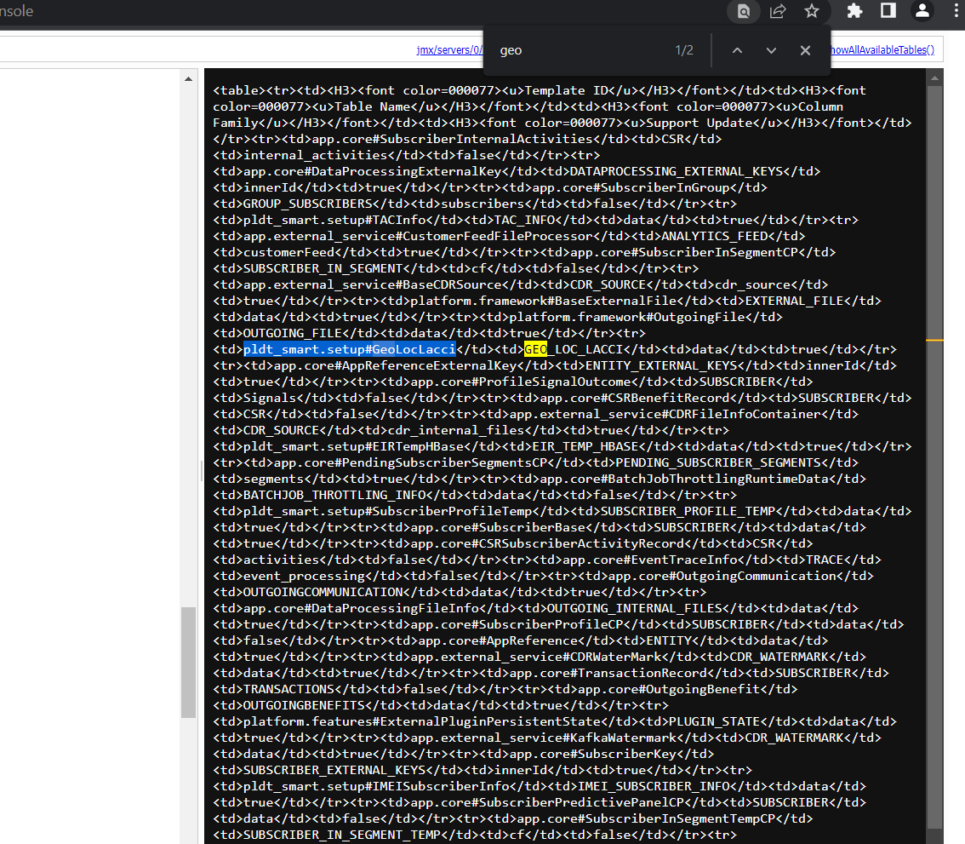

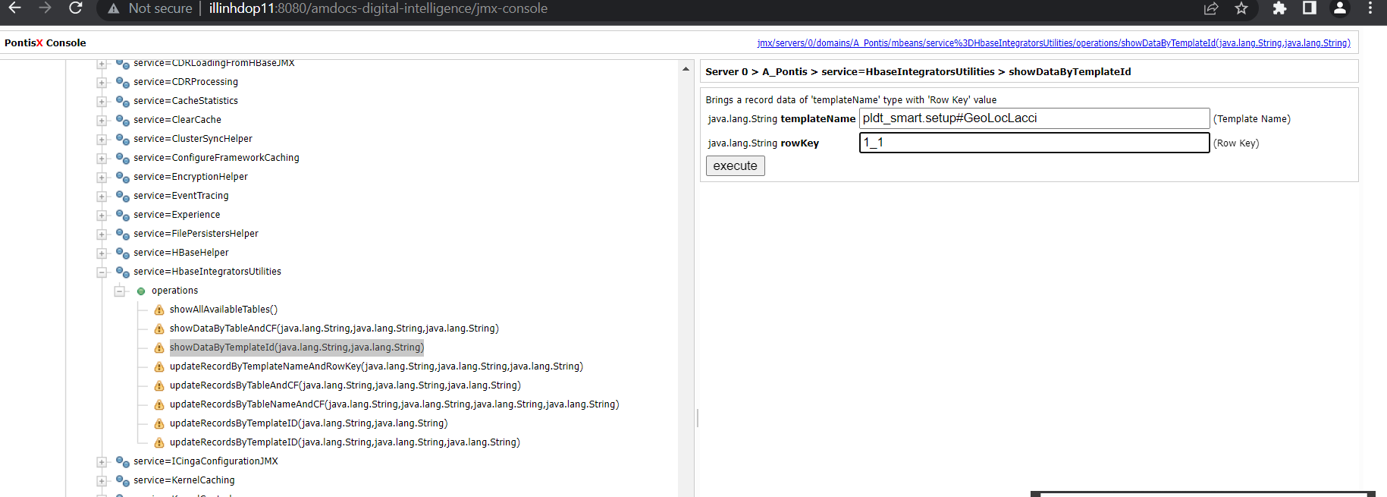

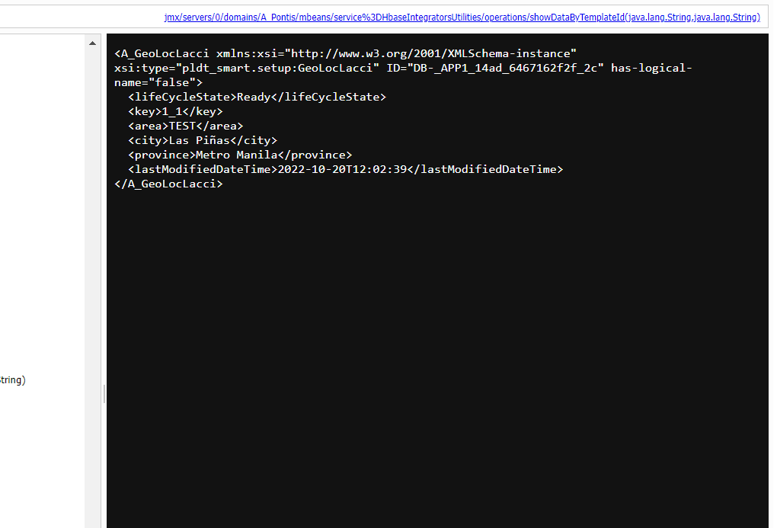

|  |  |
| --- | --- |
| **Test Case #** | **Test Description** |
| 003 | Decisioning Flow testing using postman with correct LAC, CI and Channel name : USSD_Retailer |

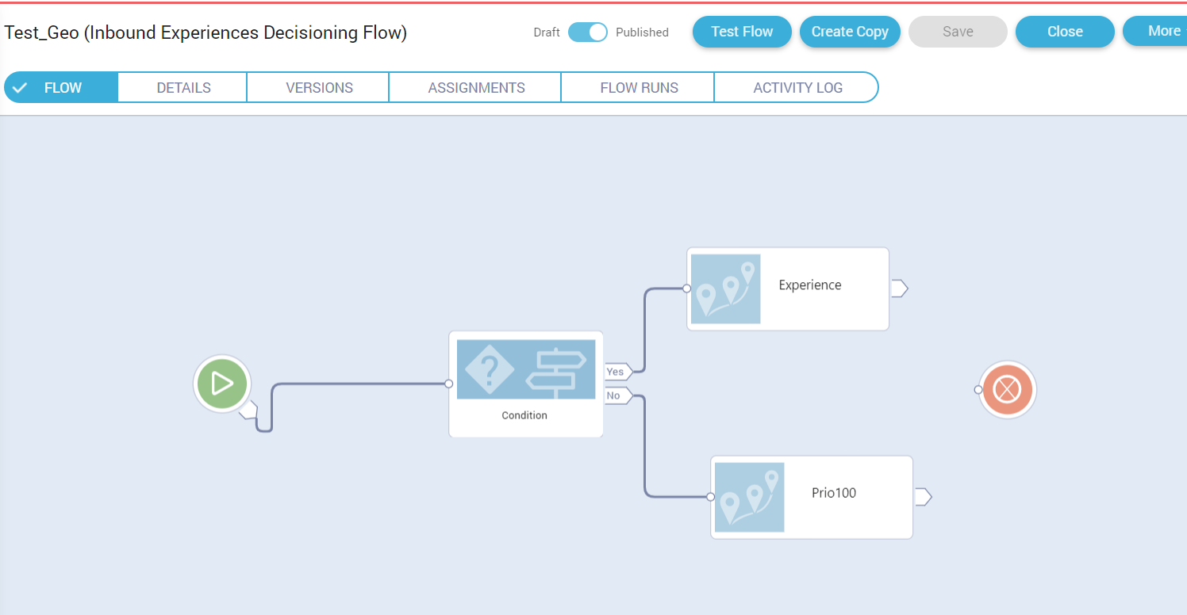

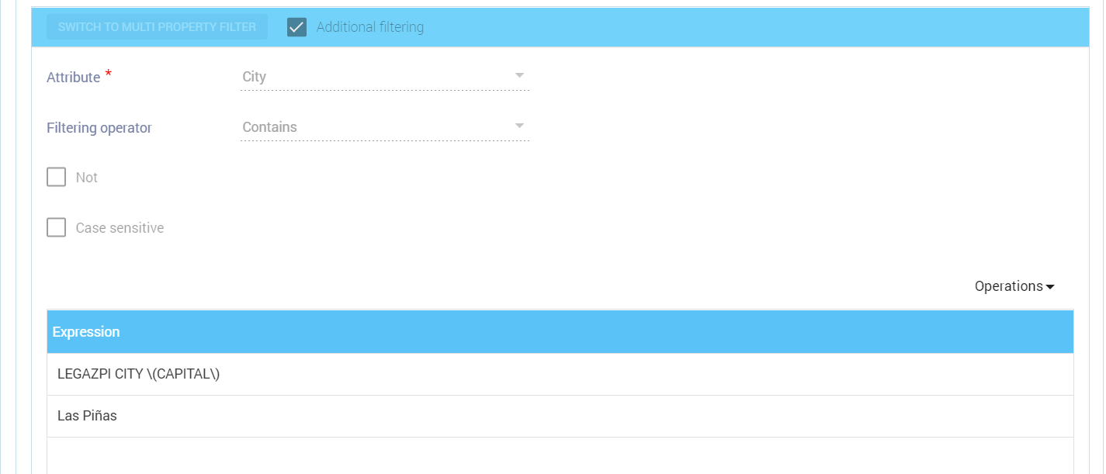

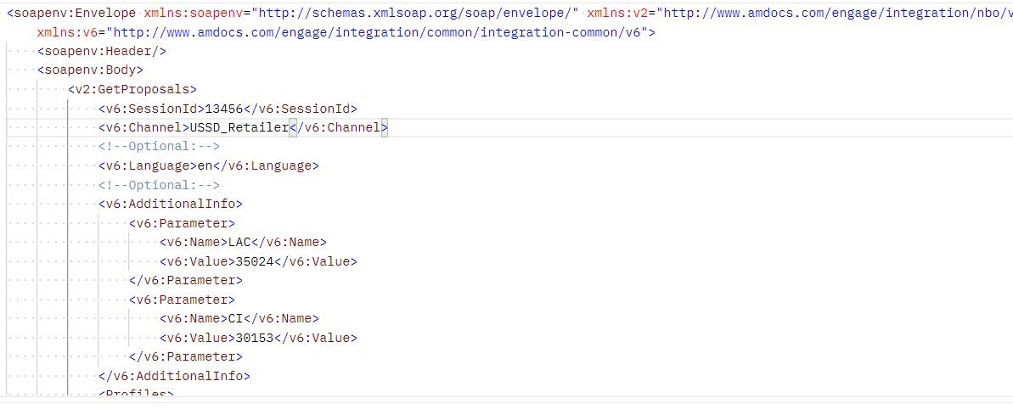

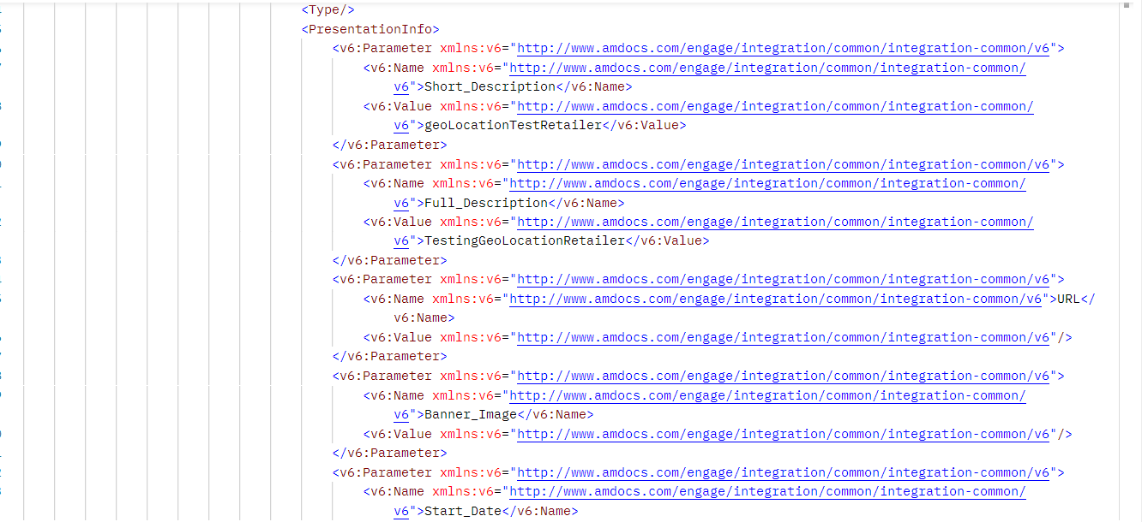

|  |  |
| --- | --- |
| **Test Case #** | **Test Description** |
| 004 | Decisioning Flow testing using postman with correct LAC, CI and Channel name : USSD_Consumer |

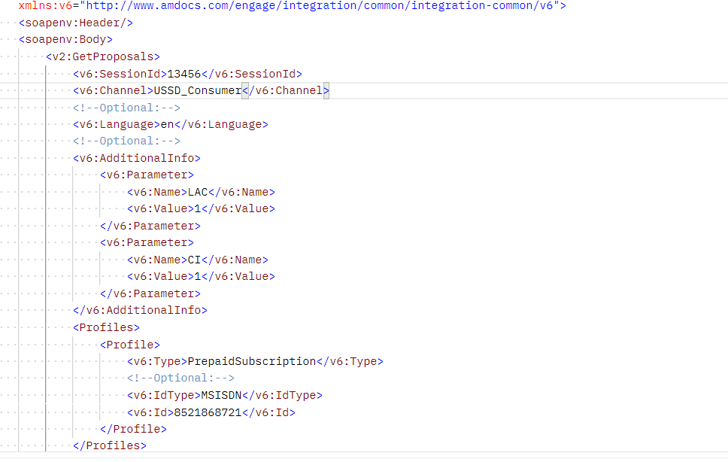

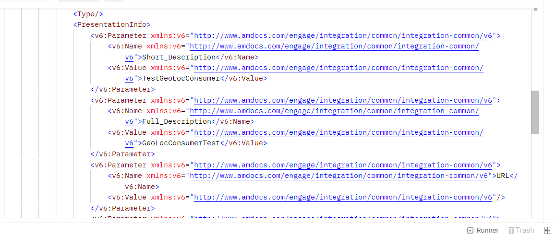

|  |  |
| --- | --- |
| **Test Case #** | **Test Description** |
| 005 | Decisioning Flow testing using postman with and correct channel name, ci and LAC but condition does not pass |

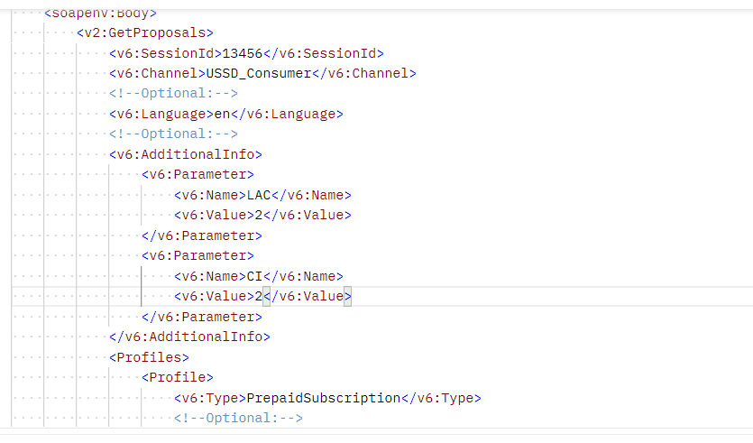

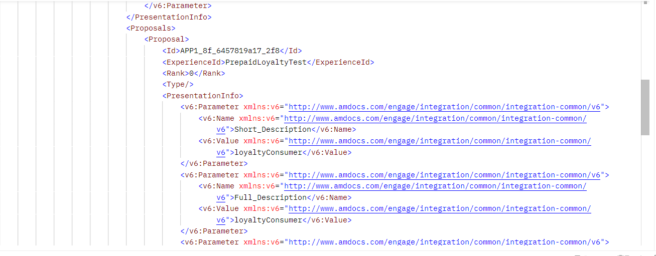

|  |  |
| --- | --- |
| **Test Case #** | **Test Description** |
| 006 | Decisioning Flow testing using postman with correct channel but CI and LAC empty |

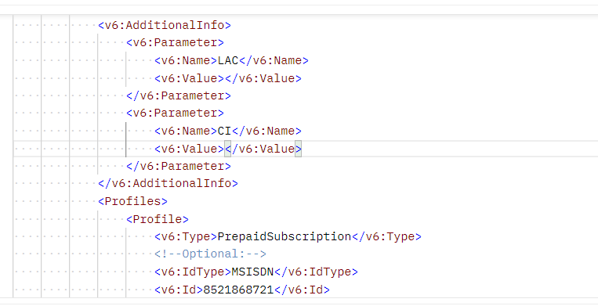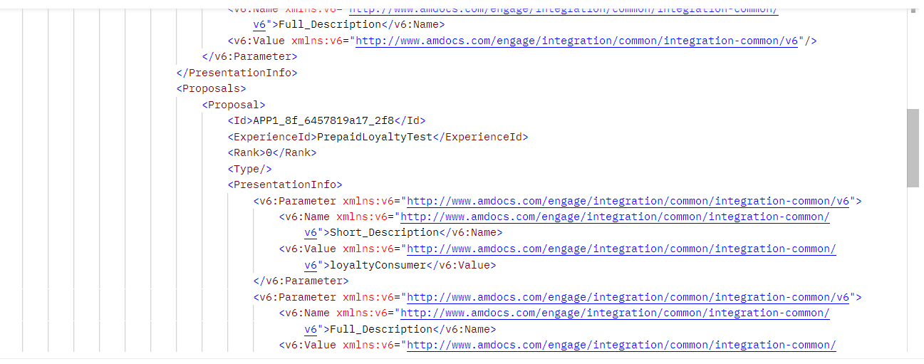

|  |  |
| --- | --- |
| **Test Case #** | **Test Description** |
| 007 | Decisioning Flow testing using postman with unknow channel |

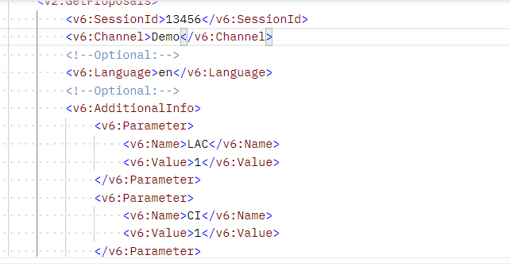

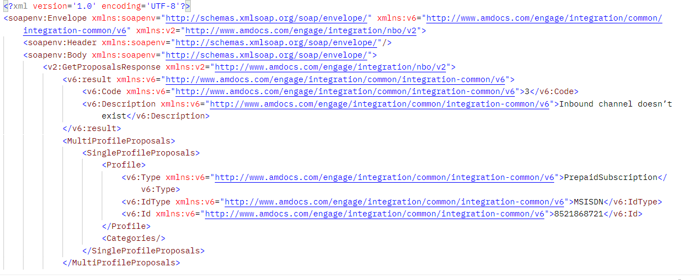

|  |  |
| --- | --- |
| **Test Case #** | **Test Description** |
| 008 | Decisioning Flow testing using postman with CI=1 and LAC=1, and for this LAC and CI, city should be “Las Piñas” |

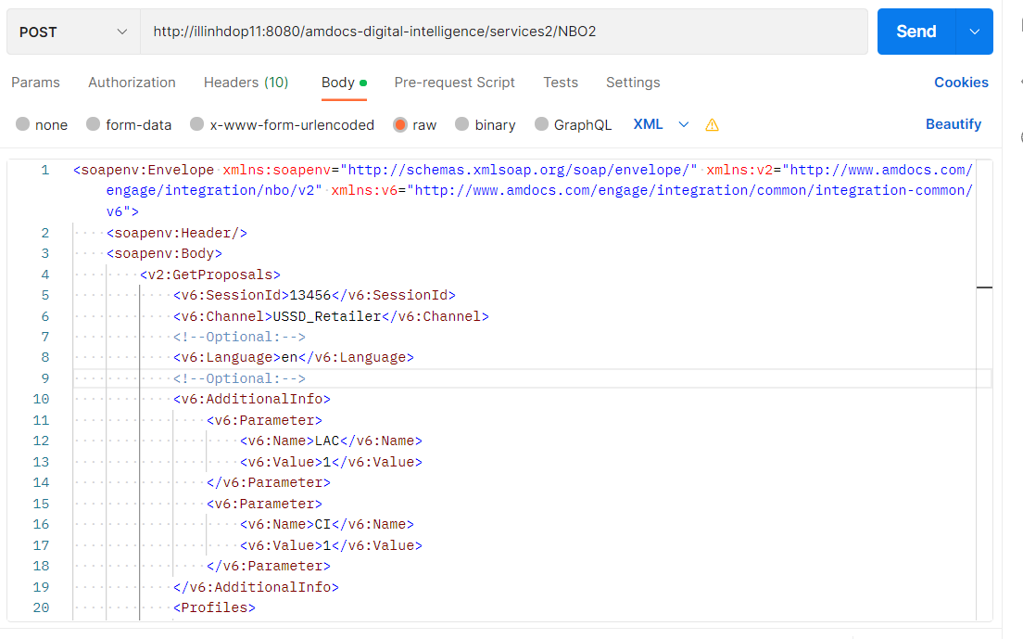

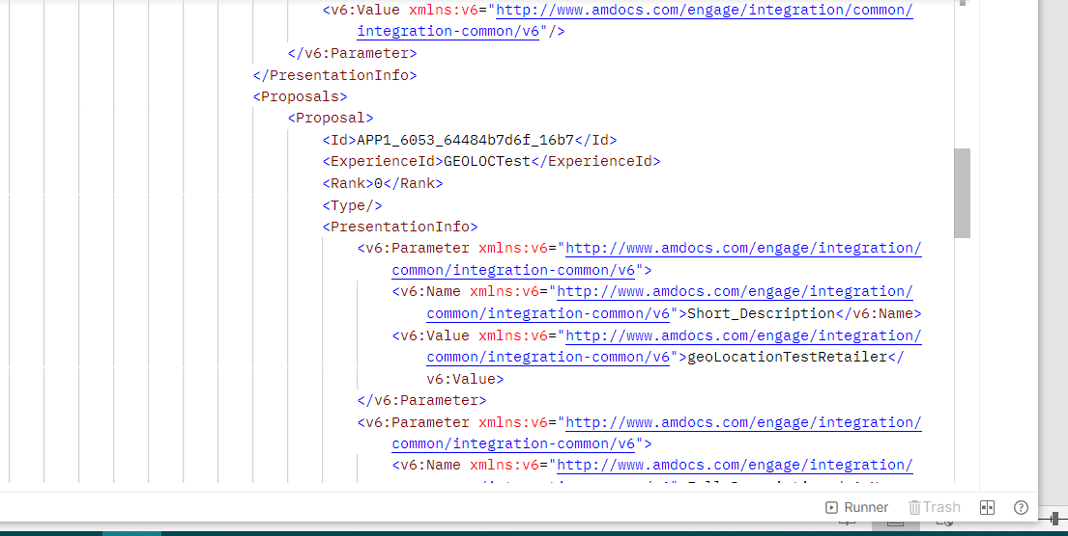

|  |  |
| --- | --- |
| **Test Case #** | **Test Description** |
| 009 | Don’t add LAC and CI parameter in getProposal |

